- We have cut our UK CPI inflation forecast over the next year, largely reflecting falls in energy prices following news of a US-Iran ceasefire agreement. But we emphasise that the inflation outlook remains very uncertain.
- Inflation held steady in May, undershooting expectations. This was due to the offsetting effects of lower food prices and rises in some services sub-categories. Inflation remains on track to rise over the coming months.
CPI inflation was flat at 2.8% in May, slightly below consensus expectations. A softening in food price inflation was the main source of May’s downside surprise, while core goods prices also cooled. But these forces were offset by one-off upward pressures in the services category, as air fares rebounded after April’s drop and a strong base effect for vehicle excise duty kicked in. RPI rose 0.1ppt to 3.1% in May, while RPIX inflation was steady at 3%.
Inflation will rise over the coming months, with Ofgem’s new energy price cap set to lift household energy bills by 13% from July. But the lower starting point from today’s data and recent falls in oil and gas prices, following news that the US and Iran will sign a ceasefire agreement later this week, mean we now expect headline inflation to peak around the 3.5% mark towards the end of this year. Thereafter, powerful base effects caused by this year’s increases in fuel and energy prices are likely to pull inflation back towards the 2% target in H2 2027.
Although recent developments have weighed on our inflation projections, the outlook is still very uncertain. It’s unclear how quickly shipping activity will recover once the Strait of Hormuz reopens. Moreover, the impact of a less severe shock on firms’ price- and wage-setting behaviour is also particularly difficult to predict.
Chart 1: A softer starting point and lower energy prices have pulled down our inflation forecast
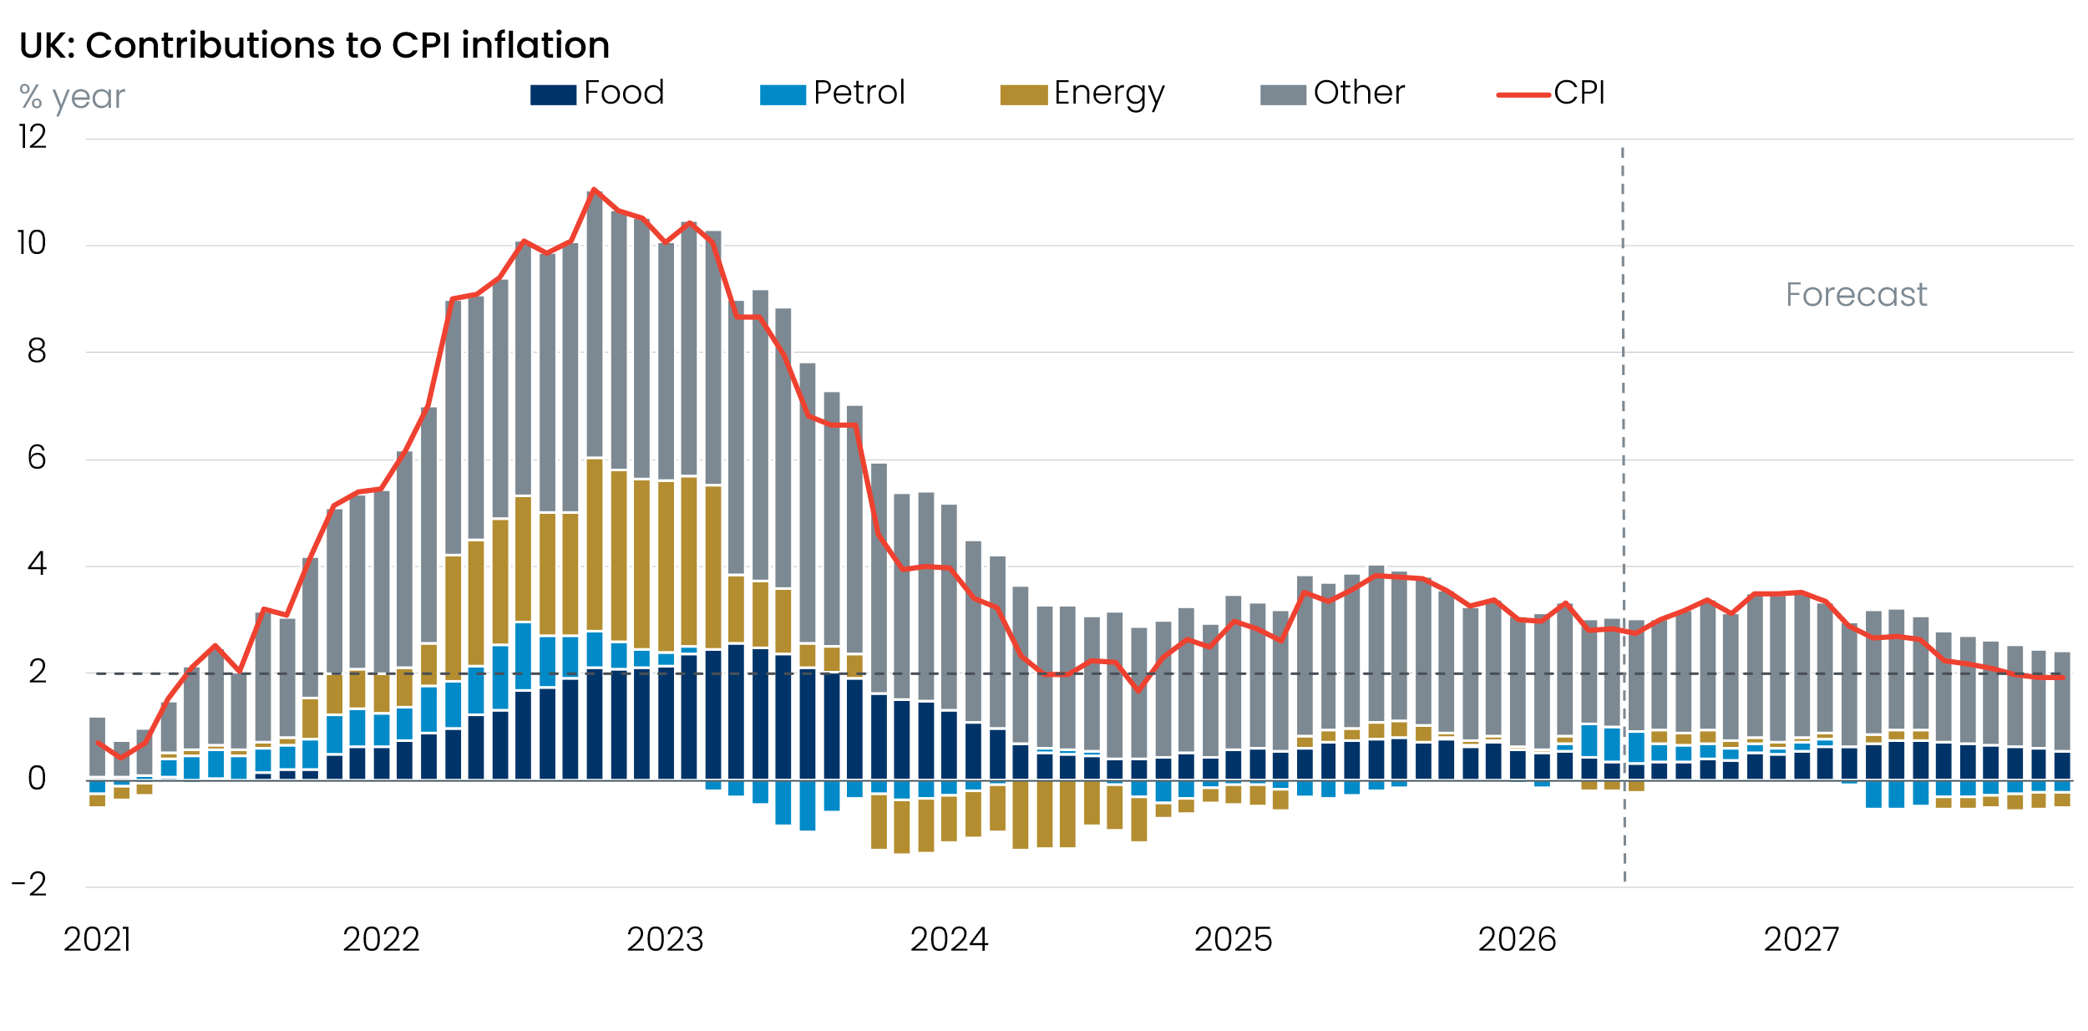
Sources: Oxford Economics, Haver Analytics

